This week, I worked on the element of interactivity in my project and added some interaction according to my design to the project. Below you can find a list of my activities this week:

1_ Station Collection:

After rendering the scatter plot that corresponds to the normalized locations of the considered stations, I am adding the ability to select a specific station to retrieve the data and visualizes the data in the future. To do so, I am adding the selection capability using the left click of the mouse. Upon clicking, the color of the selected station is turned red showing that it was selected and the name of the station is also rendered on the screen. Note that we cannot select no more than one station.

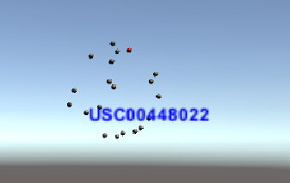

2_ Year Controller Selection

Similar to the stations, we also need to specify a year for retrieving the desired data. To do so, I added a similar capability to the design with which we can select the desired year out of the provided options using the left click. Upon clicking, the corresponding object is colored yellow from green and the name of the year is also visualized on the screen.

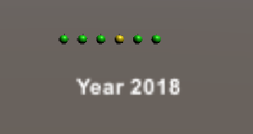

3_ Resetting

I also added a capability with which we can reset both of the selected objects from year and stations by right-clicking on the mouse.

4_ General Search

Finally, I added a general search capability to the dashboard by using keyboards (arrows) and the scroll on the mouse. The arrows can change the location of the camera vertically and horizontally and with the scroll of the mouse, we can change the depth of the screen.

Below I am providing a broader snapshot of the project so far.

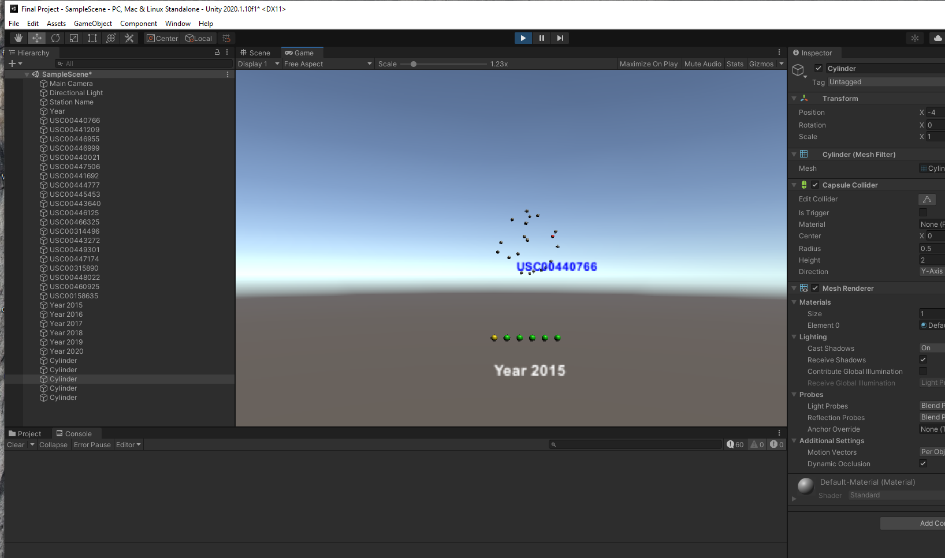

5_ To do

For the next week, I would like to work on the visualization of the retrieved data after selecting a year and a station, that would pop up on the screen.